# Hardware and Devices

Hardware and Devices 1

Using Your Existing Windows 7 Computer 1

What Is a Windows 8 Computer? 3

Core System Requirements 3

Optional System Requirements 5

Tablet Requirements 6

Interacting with Hardware 7

Devices Charm 8

Devices in PC Settings 9

Try this: Hardware and Devices 10

#### Timing for This Module

|  |  |
| --- | --- |
| Delivery Length: 45 Minutes | Additional Lab Time: 15 Minutes |

#### Overview

Windows 8 is a fundamental reimagining of the Windows experience, all the way from the firmware to the hardware to the operating system to the apps. Building on the great work that Microsoft did for Windows 7, Windows 8 will run on a broad variety of existing hardware, which means that's running Windows 8 on the computer you already own will continue to be a great experience, assuming that the computer is logo certified for Windows 7. At the same time, we have worked closely with our hardware partners to define the right baseline configuration for Windows 8 computers to provide the best possible experience on new computers.

This section will talk about some of the things that you need to know in order to continue using your existing hardware to run Windows 8, and we will also cover what some of those new baseline hardware requirements will be in order to receive the Windows 8 logo.

## Using Your Existing Windows 7 Computer

One of our major goals was to make sure that Windows 8 works great with the hardware and peripherals you already have. One of the goals with Windows 8 was to be able to install and provide a great experience on any PC that carried the Designed for Windows 7 logo. While some software and devices will require updates provided by the manufacturer, we are committed to supporting any device with the Windows 7 logo. Occasionally the manufacturer will decide that a computer or peripheral is not supported and will say so on their website. Software utilities such as security, management, and disk tools are normally tied very closely to the specific Windows version they were designed for and will require updates from the manufacturer.

The hardware recommendations for upgrading to Windows 8 include:

* 1 GHz or faster processor
* 1 GB RAM (32-bit) or 2 GB RAM (64-bit)
* 16 GB available hard disk space (32-bit) or 20 GB (64-bit)
* DirectX® 9 graphics device with WDDM 1.0 or higher driver

**Note**: Windows XP display drivers are no longer supported.

This setup gets you going with Windows 8 such that it is functionally equivalent to Windows 7, but at the same time you should see measureable improvements in performance in a number of dimensions with a system at this level.

One new element for Windows 8 related to screen resolution is that **Windows Store apps require a** **minimum of 1024x768 to open, and 1366x768 for Snap**. If you attempt to launch a Windows Store app with less than this resolution (e.g. 800x600, 1024x600) you will receive an error message.

We chose to allow Windows 8 to install even when a system doesn’t meet this requirement because, even without Windows Store apps, your Windows 7 workloads on these computers will improve and you can benefit from all the other features of Windows 8, including enhancements to the desktop. Both the Start screen and PC Settings scale well on 800x600 resolution screens.

Although there are a number of existing Windows 7 touch devices and many are fully supported, we do recognize the touch experience of Windows 8 places a greater demand on a high quality experience than could have been foreseen when manufacturers were developing hardware for Windows 7. A vast majority of Windows 7 touchscreens will perform well for Windows 8. This means that touch drivers continue to load and you’ll be able to perform basic touch interactions with a reasonable degree of success.

It is also worth noting a couple of other features that have specific hardware requirements.

**Note:** Be careful whenever you adjust your BIOS settings.

* If your existing PC was using Windows XP display drivers, you may need to upgrade your display adapter. Windows XP Display Drivers (XDDM) are no longer supported in Windows 8. You can use existing WDDM 10. (from Windows Vista), WDDM 1.1 (Windows 7), or if available WDDM 1.2 (Windows 8) display drivers.
* Secured Boot requires a new **UEFI BIOS**, which is not available broadly on computers yet, but is starting to be made available. If your computer does have UEFI, you can enable it via BIOS settings.
* Hyper-V® requires a 64-bit system with **second level address translation (SLAT)** capabilities and an additional 2 GB of RAM. You can also enable SLAT via a BIOS setting.
* Some games and other software require **graphics capabilities compatible with DirectX 10** or higher (including some games available in Windows 8 and in the Windows Store. We will continue to improve the verification of your system prior to downloading or running software with these requirements). Some games and programs might require a graphics card upgrade for optimal performance.
* If you clean install instead of upgrade, you should check both Windows Update and your computer manufacturer's website to make sure you **install any specific drivers** that they provide there. Many laptops will get better battery life with a power-optimized driver that is specific for that computer (often known as ACPI, Power, or Chipset driver).
* •BitLocker™ does not require but performs more seamlessly if your computer has a **Trusted Platform Module (TPM).** Computers that have this sometimes require it to be enabled via BIOS settings.

## What Is a Windows 8 Computer?

A Windows 8 computer is one that carries the Designed for Windows 8 logo. In order for a computer to receive this logo, it must support a minimum experience and hardware level, and include specific components. The requirements for creating a Windows Certified System are created by Microsoft to help ensure that customers have a high quality and consistent experience with Windows 8 on any computer that carries the logo.

Here, we are going to talk about some of these requirements, with a focus on those that are likely to affect your support. This will help us all understand what to expect from a Designed for Windows 8 computer. The requirements fall into two categories:

* Requirements that apply to all Windows 8 computers
  + This would include things like using UEFI instead of the legacy BIOS.
* Requirements that only apply if a particular experience is implemented
  + An example of this would be touch support. Not all computers require touch, but if it is implemented there are requirements that help ensure an excellent quality bar.

In general, Windows RT requirements are not discussed in this module if they are specific to Windows RT. This information can be found in the Windows RT module.

For more information about the various hardware and device requirements required for the Windows logo program, you can view the hardware requirements documents at the link below.

**Windows 8 Hardware Certification Requirements**  
<http://msdn.microsoft.com/library/windows/hardware/jj128252>

### Core System Requirements

PCs with the Designed for Windows 8 Logo are indicating that they meet a minimum set of baseline requirements, both related to the hardware that is included with the PC and the experience provided by the PC. Some of the more important examples of these minimum requirements are listed below. This is not an exhaustive list however.

Table : Core system requirements

|  |  |
| --- | --- |
| **Component** | **Requirement** |
| Storage | At least 10GB of free space after completing Windows Welcome. This must be free space available to the user over and above any space used for preinstalled apps or recovery utilities. |
| System Firmware | UEFI is the core prerequisite of the Windows 8 platform that enables key features in security and performance. All Windows 8 computers must be able to boot into UEFI boot mode and attempt to boot into this mode by default. All versions of Windows 8 are UEFI-compatible.  UEFI is the new model for firmware in computer devices. UEFI is a replacement for legacy BIOS technology, and provides several important advantages over BIOS-based firmware.   * Support for mouse and GUI configuration interfaces * Support for installing Windows on GPT volumes, which are required to boot from a hard disk that is larger than 2.2TB * Much faster boot time, sleep and resume time * Support for new power management models, such as Connected Standby.   Many computers provide the ability to switch modes between BIOS and UEFI. This is useful because 32-bit Windows does not support booting on a UEFI computer, so they can switch to BIOS mode in order to install that architecture of Windows. BIOS mode is only allowed for systems that ship with 32-bit Windows. This allows OEMs to maintain one firmware image for both 64-bit and 32-bit deployments. All systems must be UEFI mode capable and also pass 64-bit UEFI logo requirements.  The System firmware must be able to boot to UEFI mode by default. A computer may also support fallback to legacy BIOS mode boot for deploying OS images which do not support UEFI, if the user explicitly selects that option in the pre-boot UEFI BIOS menu.  All client systems must support UEFI Secure boot. Secure Boot must be enabled by default, and a mechanism for disabling secure boot must be provided. |
| Graphics | Minimum Resolution – 1366x768  1080p Video playback without glitches  Video drivers capable of updating without a reboot  On a computer with an accelerometer, the WDDM driver is required to support all rotated modes for every resolution enumerated for the integrated display.  Must provide WDDM 1.2 drivers, which adds support for smooth rotation, 3D stereo, and D3D11 video support |
| CPU | CPUs must now support the following features:   * PAE - Physical Address Extension * NX – No Execute * SSE2 – Streaming SIMD Extensions 2   In order to support Hyper-V, the CPU must also support SLAT (Second Level Address Translation) |
| Resume | Systems must resume within 2 seconds |

### Optional System Requirements

The requirements shown below specify the baseline requirements for a particular class of hardware only if it is implemented in the computer. For example, supporting touch is not required as a core requirement, but if the device implements touch, it must support at least 5 simultaneous touch points, which is part of the baseline requirement for touch devices. Some examples of optional components are shown in the table below, though this is not an exhaustive list.

Table : Optional system requirements

|  |  |
| --- | --- |
| **Component** | **Requirement** |
| Touch | If touch is implemented it must support a minimum of 5 simultaneous touch points and it must be firmware updatable. Touch response time, meaning the time between when the user touches the glass and the interface responds must not exceed 100 milliseconds. |
| NFC | Near Field Communication (NFC) devices are a new class of devices supported in Windows 8. NFC is a wireless technology designed to communicate specifically with other NFCs that are very nearby (just a few inches). NFC can be used to setup online games, share contact information, or authenticate your computer simply by placing your computer with an embedded NFC radio next to another computer or device with an NFC radio.  Windows 8 PCs that implement NFC must implement a visible “touch mark” on the exterior indicating the location of the NFC radio. This will enable you to easily find the right location to tap on the device to use NFC. |
| Mobile Broadband | Mobile Broadband devices will become much more prevalent in the Windows 8 timeframe, and Windows 8 includes native Mobile Broadband support and a Mobile Broadband class driver. A logo certified Windows 8 computer with a mobile broadband device will be able to configure and use that mobile broadband device without needing to install any additional software from the IHV. All internal USB-based mobile broadband devices integrated into a certified Windows 8 computer will function using only the Microsoft class driver for Mobile Broadband.  If a mobile broadband device is integrated into a tablet or convertible system, then an assisted GPS radio is required. |

### Tablet Requirements

Microsoft has defined special requirements for Windows 8 computers that come in the Tablet or Convertible form factors.

* A **tablet form factor** is defined as a standalone device that combines the computer, display and rechargeable power source in a single chassis, but does not include a permanently attached keyboard and pointing device.
* A **convertible form factor** is defined as a standalone device that combines the computer, display and rechargeable power source with a mechanically attached keyboard and pointing device in a single chassis. A convertible can be transformed into a tablet where the attached input devices are hidden or removed leaving the touch display as the only input.

A tablet or convertible must support the following minimum requirements.

Table : Tablet requirements

|  |  |
| --- | --- |
| **Component** | **Requirement** |
| Touch | Must be certified Windows 8 touch hardware, meaning that it supports at least five touch points and is firmware updatable. |
| Networking | Must include with both WLAN and Bluetooth 4.0 + LE (low energy). |
| Camera | Must support capturing both still images and video and a minimum resolution of 720p. |
| Included Sensors | The following sensors must be included, and these sensors must work with the [Windows Sensor and Location Platform](http://msdn.microsoft.com/en-us/library/windows/hardware/gg463473.aspx).   * Ambient light sensor – Detects the light levels of the surrounding environment to enable features like adaptive brightness. * Magnetometer – Detects the strength or direction of magnetic fields, used for things like compasses. * Accelerometer – Measures acceleration and motion along 3 axes. Useful for mobile gaming scenarios. * Inclinometer – Detects the angles that a device is tilted, also useful for gaming. * Gyroscope – Also measures orientation. * Compass – Used to determine location and direction. * Device Orientation – Device orientation is used to determine way that a device is being held in 3d space. This sensor draws data from other sensors like the Accelerometer, Inclinometer, and Gyroscope to infer a new data type using a feature called Sensor Fusion. |
| USB 2.0 | At least one controller and one exposed port. |
| Speakers | Speakers must be integrated into the device. |
| External buttons | All tablets must have Power, Rotation Lock, Windows Key, Volume Up and Volume Down buttons.  **Note**: To support domain environment where CTRL-ALT-DEL is required, firmware must support using the Power button + the Windows key to send this key sequence.  Any buttons that are implemented on the system cannot launch any customized user interface elements. This means that external buttons are limited to the launching native Windows UI or functionality. |
| Orientation | The default orientation is in landscape mode and the Windows Key button must be on the front of the device facing the end user in the center along the bottom bezel. If the system is a convertible, the buttons must be accessible in all configurations. |
| Bezel Width | Sufficient space must be provided to allow the tablet system to be held by the end user without resulting in accidental touch input. The space provided must not exceed the maximum of 26mm, as this will negatively impact user experience around scenarios such as thumb typing and thumb navigation. |

## Interacting with Hardware

While familiar tools like Device Manager and Devices and Printers still exist in Windows 8, new interfaces for interacting with your hardware and devices in the new Windows UI have been introduced,

The first two additions that we will be discussing are the Devices charm and the **Devices** section of PC settings. Both of these interfaces will show you externally attached devices, either connected directly such as by USB, over the Ethernet network, or over a wireless technology like Bluetooth or Wi-Fi Direct.

### Devices Charm

The Devices charm will show you the devices that are relevant for the app you are using at the time. For example, opening the Devices charm while reading a web page may show you options for projecting the display on a secondary monitor and printing the article using one of your printers. Watching a movie in the Videos app would also give you the option to project the video onto another display, but would also give you the option to send the video to a PlayTo compatible network media device.

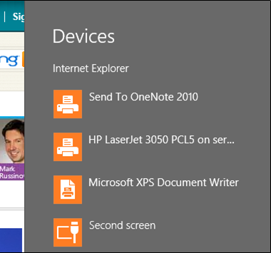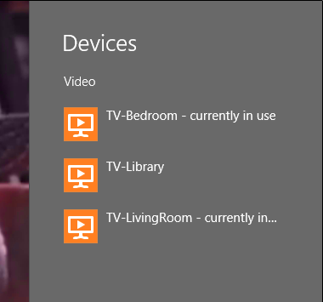

Figure : Devices charm

* Selecting a PlayTo device will stop the video or music playing locally and start the media playing on the selected device, such as your PlayTo compatible TV.

**Note:** In order for a network media device to appear in the Devices charm when playing back audio or video, the device must be a DLNA device that is PlayTo compatible, which means that it supports the Digital Media Renderer profile and carries the Designed for Windows logo.

* Selecting the **Second screen** option will take you to the <Windows Key> + P interface for configuring multiple monitors.
* Select a printer will open the print interface in the new Windows UI for the printer you selected.

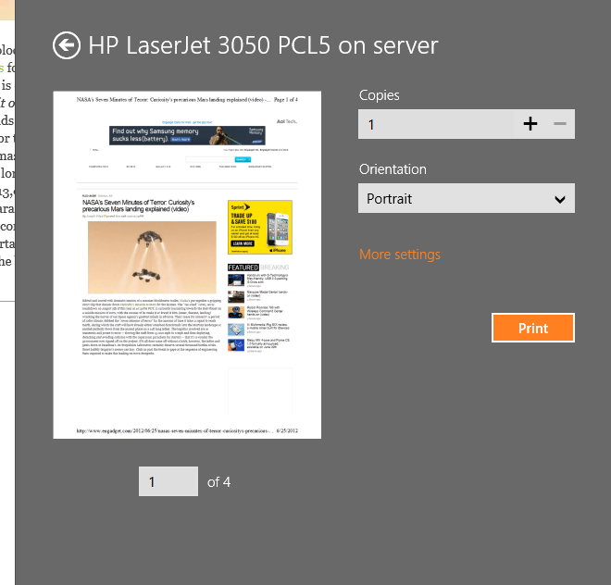

Figure : Printer interface

### Devices in PC Settings

The Device section of PC Settings provides you with a new Windows UI for interacting with your hardware. This interface is intended to provide a simple way to perform common tasks related to externally or network attached devices. This interface is not a replacement for Devices and Printers and common troubleshooting tasks such as updating drivers or disabling devices will still require you to use Device Manager. However, this does provide an intuitive and touch friendly way for managing some devices.

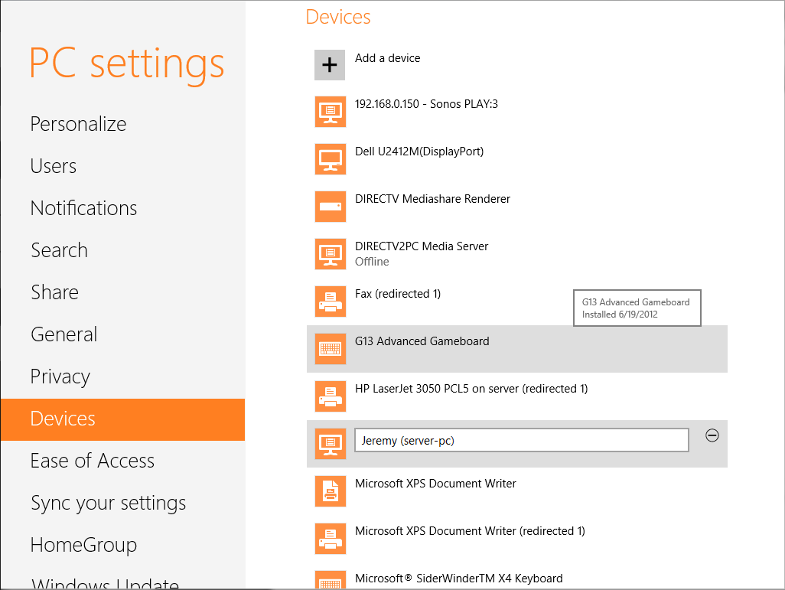

Figure : PC Settings

Here are some of the tasks that you can perform in the **Devices** section of PC Settings:

* View the current status of the device if it is in a problem state, such as the device could not start or is offline.
* Rename any network media devices to make them easier to distinguish from each other.
* Uninstall a device.
* Hover your mouse over a device to see when it was installed.
* Add a network or Bluetooth device, such as a mobile phone.

## Try this: Hardware and Devices

1. If you have access to a Bluetooth adapter, use it to pair your mobile phone to the computer using **Devices** in PC Settings.
2. If you have access to a printer, connect to that printer and use the Devices charm to view the print properties.
3. Compare the printer properties for the printer you attached and the Microsoft XPS Document Writer.
4. Connect a USB flash drive and verify that it appears in Windows Explorer. Uninstall the flash drive using **Devices** in PC Settings. Is the flash drive still visible after doing so?